Walk 36 Ullingswick
Last walked in May 2018

Description. A 9 km (5.6 mile). A summer or winter walk along narrow roads, thru woodland and along well defined tracks. Good scenery. One stiff road climb. No stiles. (Edited copy from Hereford Times May 2013).
Start. St Luke’s Church, Ullingswick. Explorer Map 202 Grid 596499.
Direction from Whitecross roundabout (Turn milometer to zero). Take the A4110 Canon Pyon (Three Elms road) for 1 mile and TR at the traffic lights onto the A4103 to Worcester (Roman road). Go thru two roundabouts and at 3.7 miles TL onto the A465 to Bromyard. At the next roundabout, (9 miles) TL onto the A417 to Leominster. At 10.1 miles TR for Ullingswick. At a T-junction by a red telephone box (10.5 miles) TR. At 11.2 miles TL for Ullingswick church. At 11.4 miles the road bends right and at 11.6 mile you reach the church car park.

1. St Luke’s church, Ullingswick. The church is on your R. Go out of the car park onto the road and TL. After ¼ km, (by a drive for Sheepcotts Court), the road bends L, continue along the road to reach a T-junction where you TR. After 35m you TL onto a wide bridle path. Go thru a small wooden/ metal gate by Tidmour Cottage (R), and continue along an enclosed path to go thru a metal gate into F1, (ignore the gate on the L hand side). Continue in the same direction along the L field edge to reach the far L corner, next to trees. TL into F2 then TR and continue alone the R field edge and along the outside edge of trees that are on your R. Reach the field corner and go on thru a strip of the wood, to reach F3. Continue in the same direction, along the R field edge, the trees are on your R. Go thru a hedge gap into F4 and continue along the R field edge. Go thru a gap into F5. A little further on, just before reaching the hedge corner, you TR and go thru a hedge gap to go quite steeply up a track into the trees.

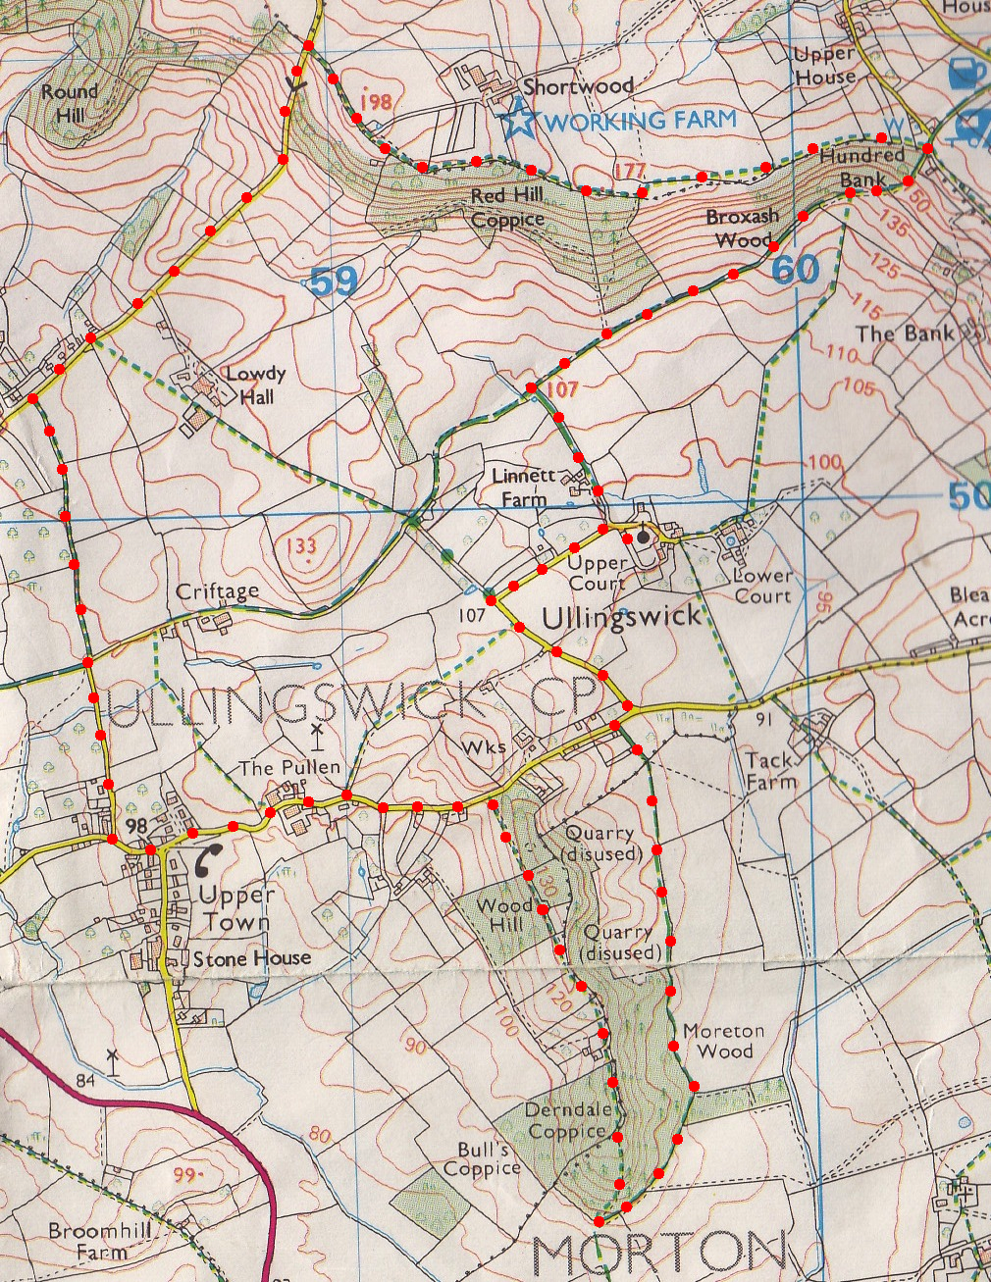
2. Derndale Coppice. Continue up and along the track, to pass a canopied building on your L. TR at the track T junction and go on thru a wooden gate and along an enclosed track, (wooden fence on either side, a cottage on L called Dovedale). The track turns into a tarmac drive. Go thru a metal gate, the tarmac breaks up into aggregated drive and continues onto a road. At the main road you TL and continue on for almost a kilometre, first passing ‘The Old School House (L), and later on a black and white house called ‘Townsend House (L), then a red telephone and post box (L). Ignore the road going L and continue on, in the same direction for about 100m, to a point just past ‘The Wilden (L), where you TR and walk along a No Entry road towards The Criftage. (About 200m further along the road, opposite Stone House, is the spot where William Hope molested then murdered Mary Corbett, a willing maidservant to the Skerretts of Ullingswick, in October 1862. William Hope was the last person to be hanged in public in Hereford. His execution took place above the gate of Hereford jail on April 15, 1863, in front of a boisterous mass of spectators. Mary Corbett was laid to rest in Ireland just a week after her murder.) After about ¼ km the road bends R and you go straight on along an enclosed grassy track. Carry on to reach a road at Lower Hope Lodge. TR and walk along the road for 1km, going steeply up hill to reach the turn off for Shortwood Family Farm at the top.

3. Shortwood Family Farm. TR and walk along wide footpath for Shortwood. Where drive goes L for Shortwood, you go straight on thru a metal gate into a field enclosure, then thru another metal gate into a bigger field. Keep to the R field edge, (Red Hill Coppice is on your R), and go thru another gate into a bigger narrow field. Continue along the R hand field edge to go thru a gate in the right hand corner and bear R along an enclosed dirt track, woods are on your R. A little further on the dirt track bends L and then R and continues on, along a wide enclosed dirt track. (Good views on your R side) When the main track goes L you carry straight on, going thru a medal gate, (Broxash Wood is on your R) and along a track that’s along the R field edge. At the fence ahead, that’s R of dwellings, TR for 25m down into trees, then TL and go thru a metal gate onto an aggregated track.
3

4. Hundred Bank path junction. Take sharp R and turn down an enclosed aggregate bridle path. After 65m the track bend L but you go straight on thru a metal gate and into F1 (Broxash Wood is on your R). Continue down the R field edge, and go thru a small metal gate in the R corner, into F2. Keep on top of the bank along the R field edge, to go thru a metal gate and along an enclosed track that’s along the inside edge of the woods. Go thru a metal gate and out into {F6}. Walk along the L field edge, thru a metal gate and along an enclosed track. When you reach a corrugated iron barn shelter (R), TL and walk along a hedged bridal path and drive, to car park.
4
2
1

